JIRA Assignment:
Design a webpage using Tilda:
Create an Epic:
Link URL: https://satheeshnandhu2000.atlassian.net/browse/SCRUM-11
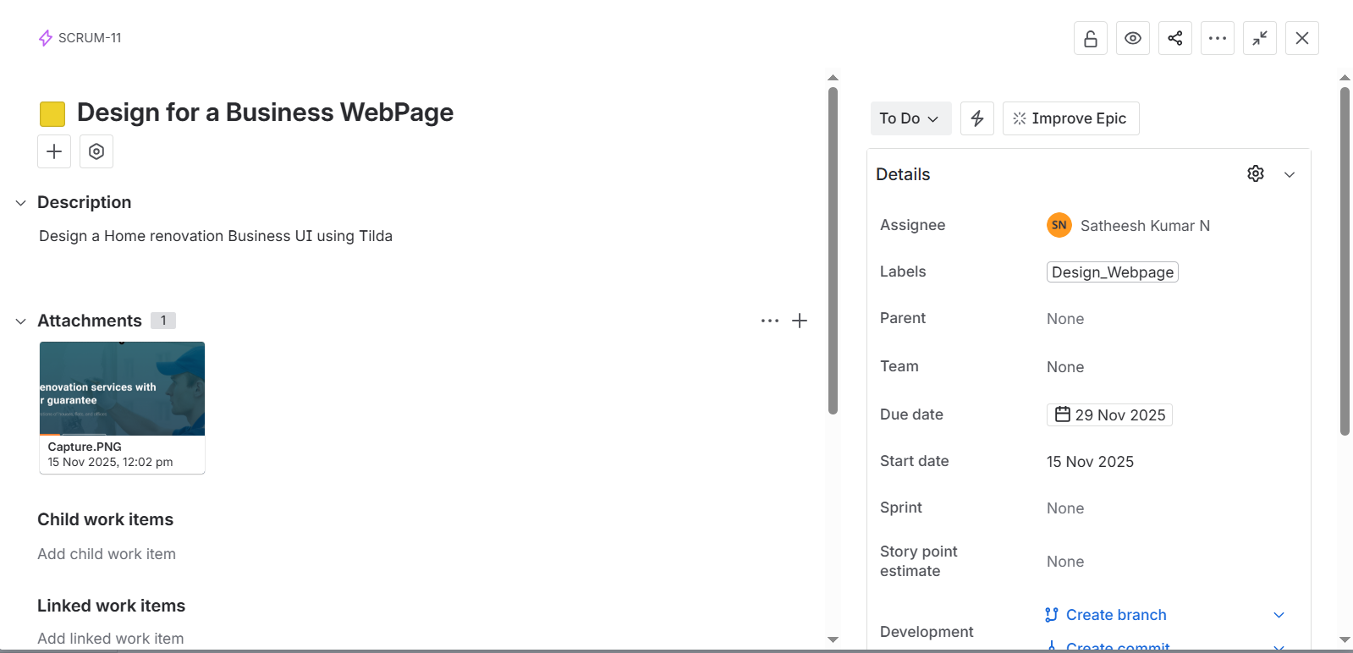
Create an User Story:
Link URL: https://satheeshnandhu2000.atlassian.net/browse/SCRUM-12
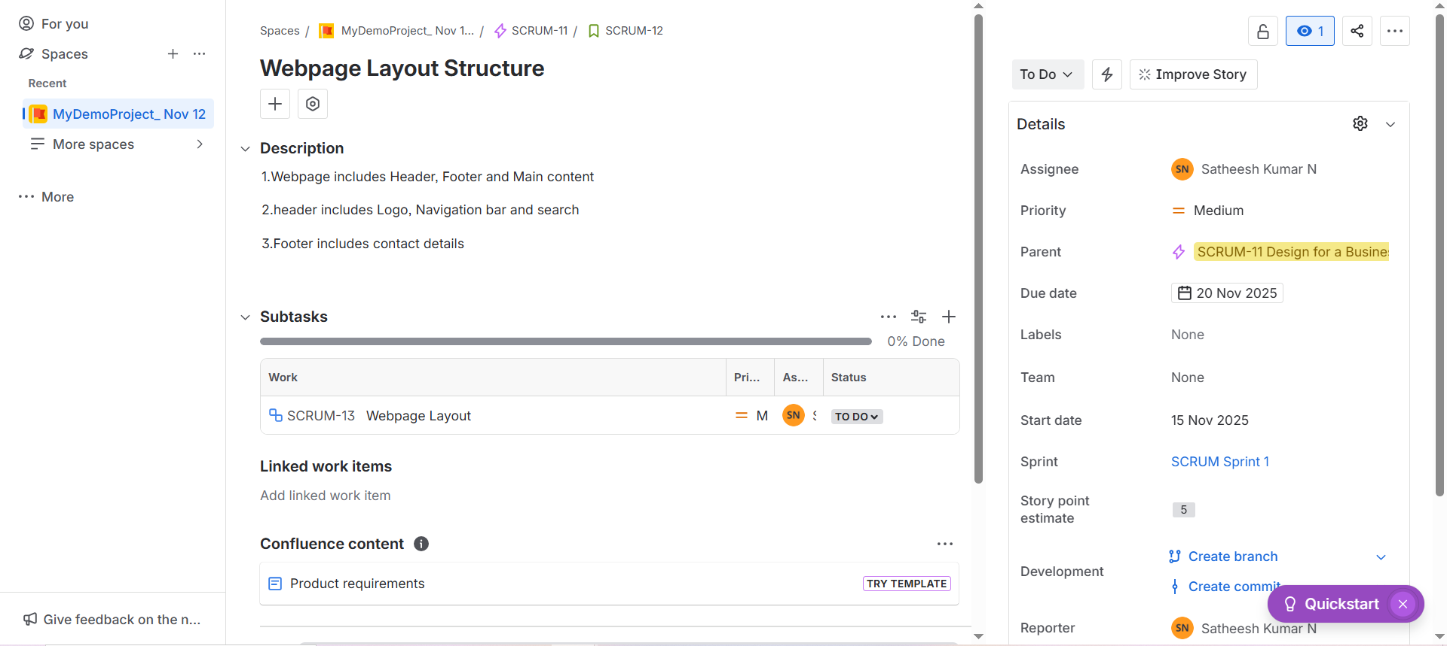

Create a Sub Task:
Link URL: https://satheeshnandhu2000.atlassian.net/browse/SCRUM-13

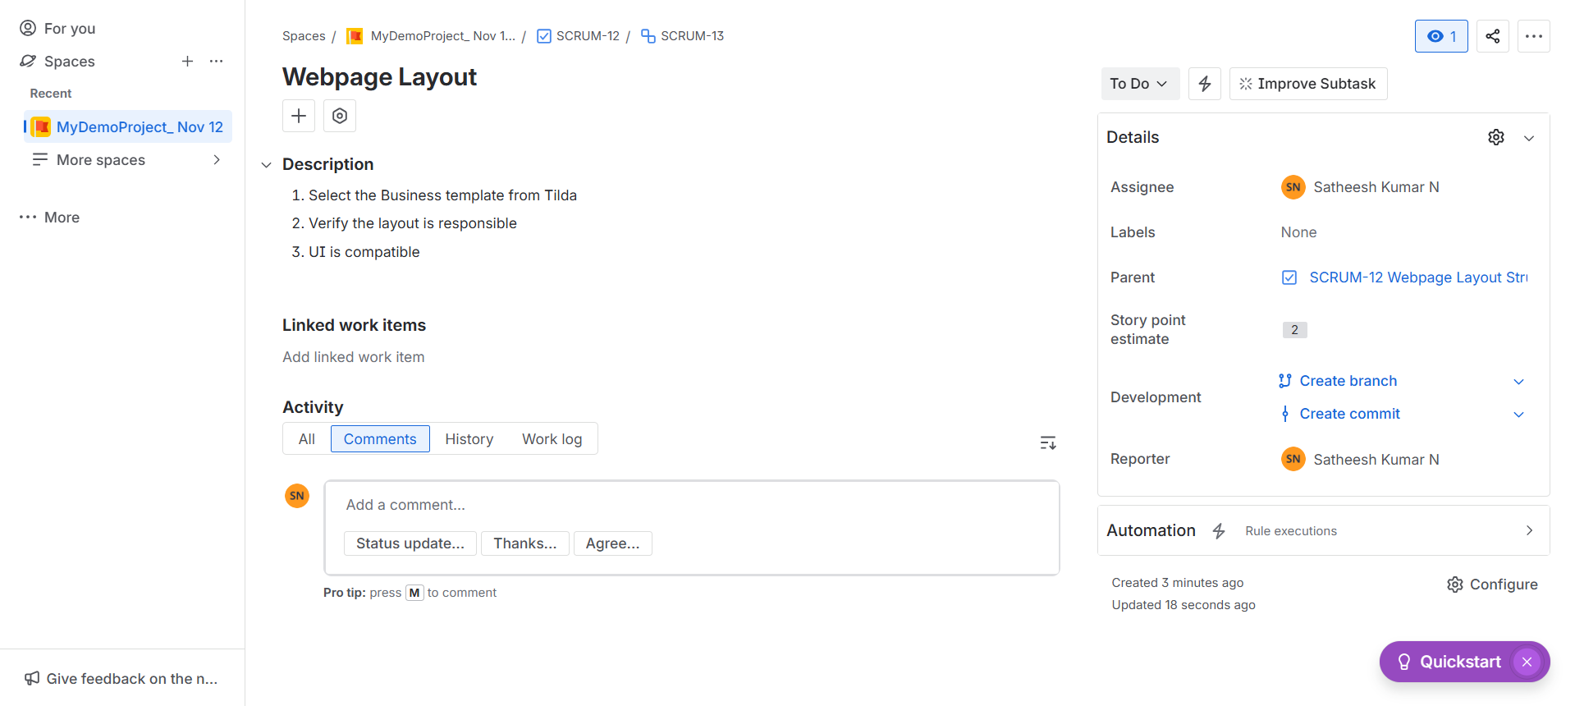

Development of a webpage using Tilda:
Create an Epic:
Link URL: https://satheeshnandhu2000.atlassian.net/browse/SCRUM-15
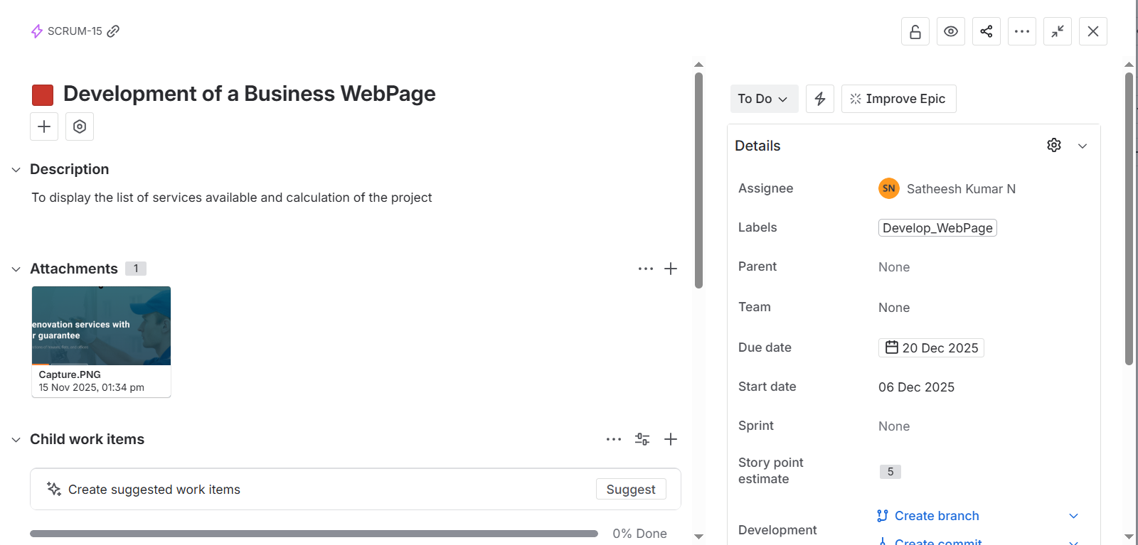

Create an User Story:
Link URL: https://satheeshnandhu2000.atlassian.net/browse/SCRUM-16
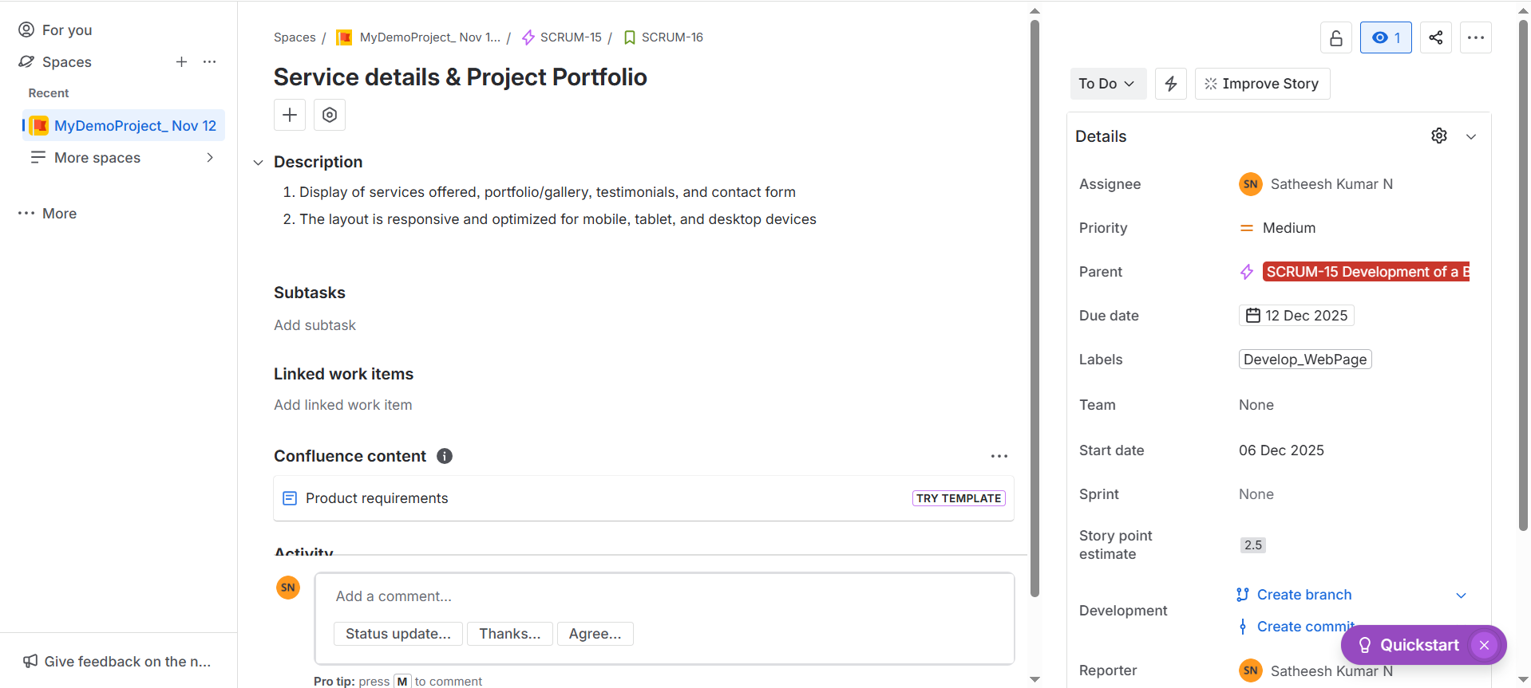

Create a Sub Task:
Link URL: https://satheeshnandhu2000.atlassian.net/browse/SCRUM-17
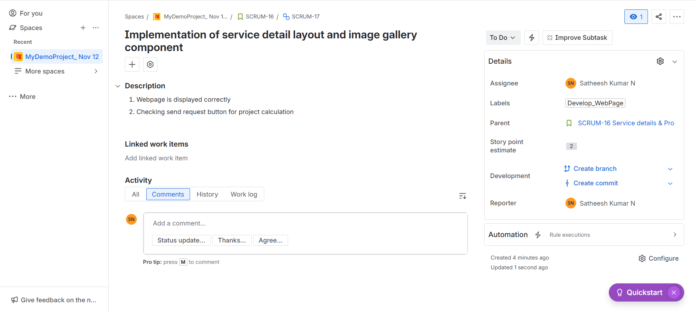

Moving User Stories from Backlog to Sprint Backlog:

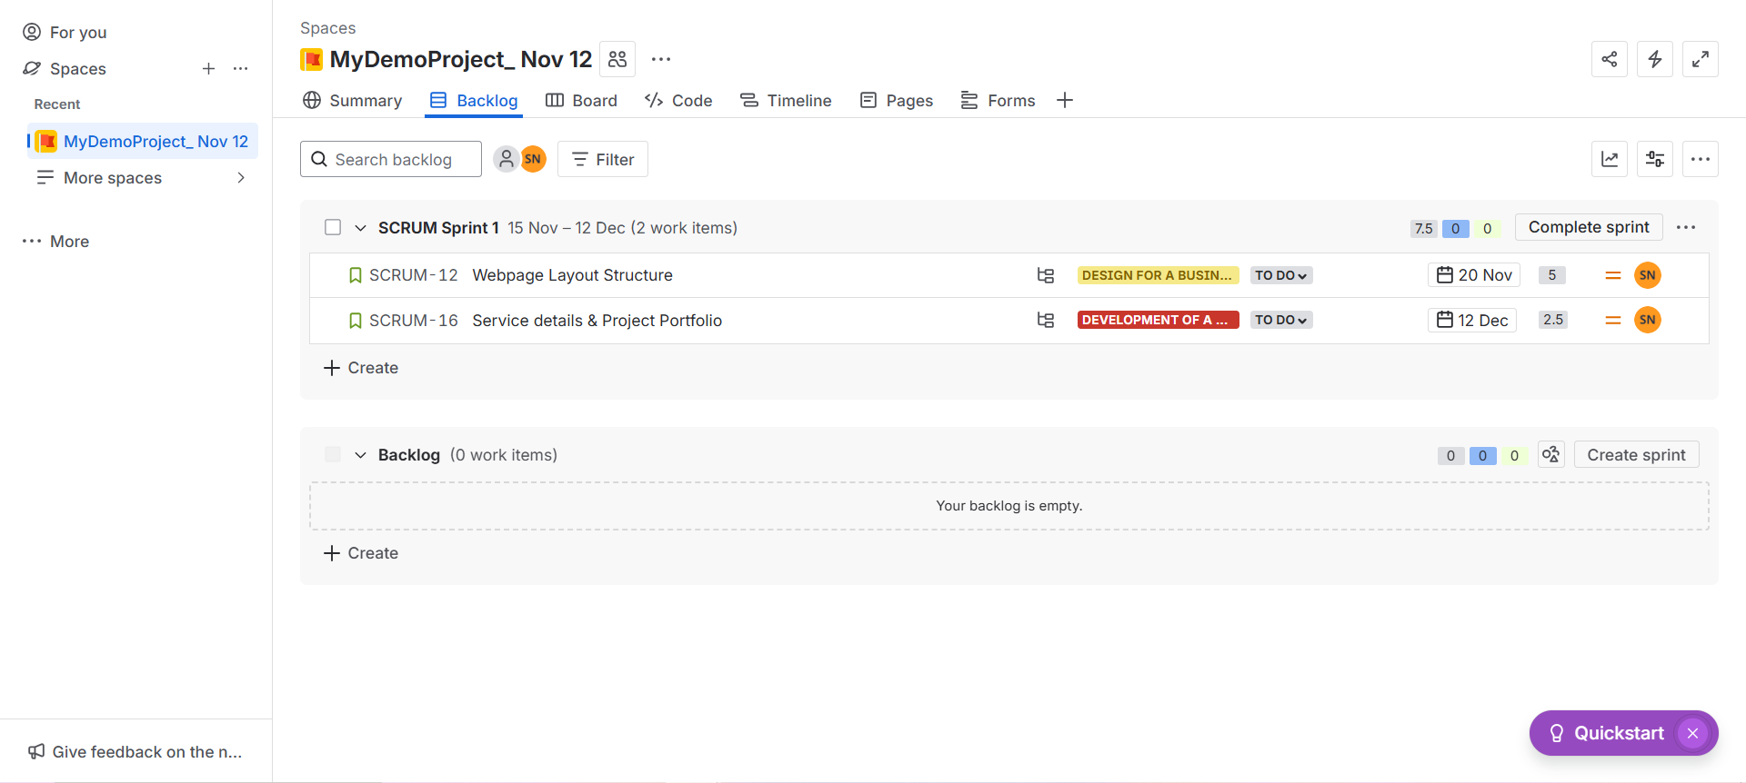
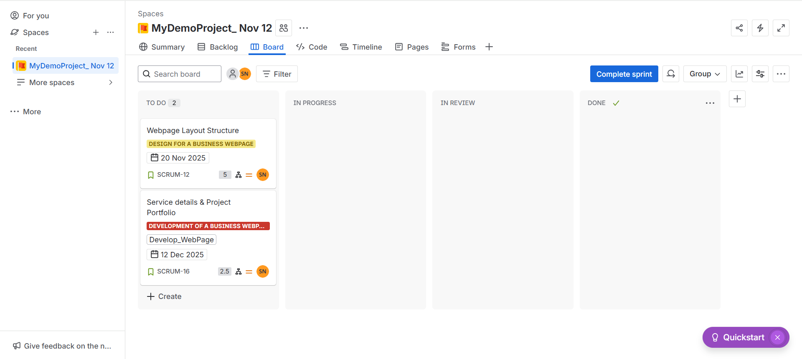
Changed status to DONE:
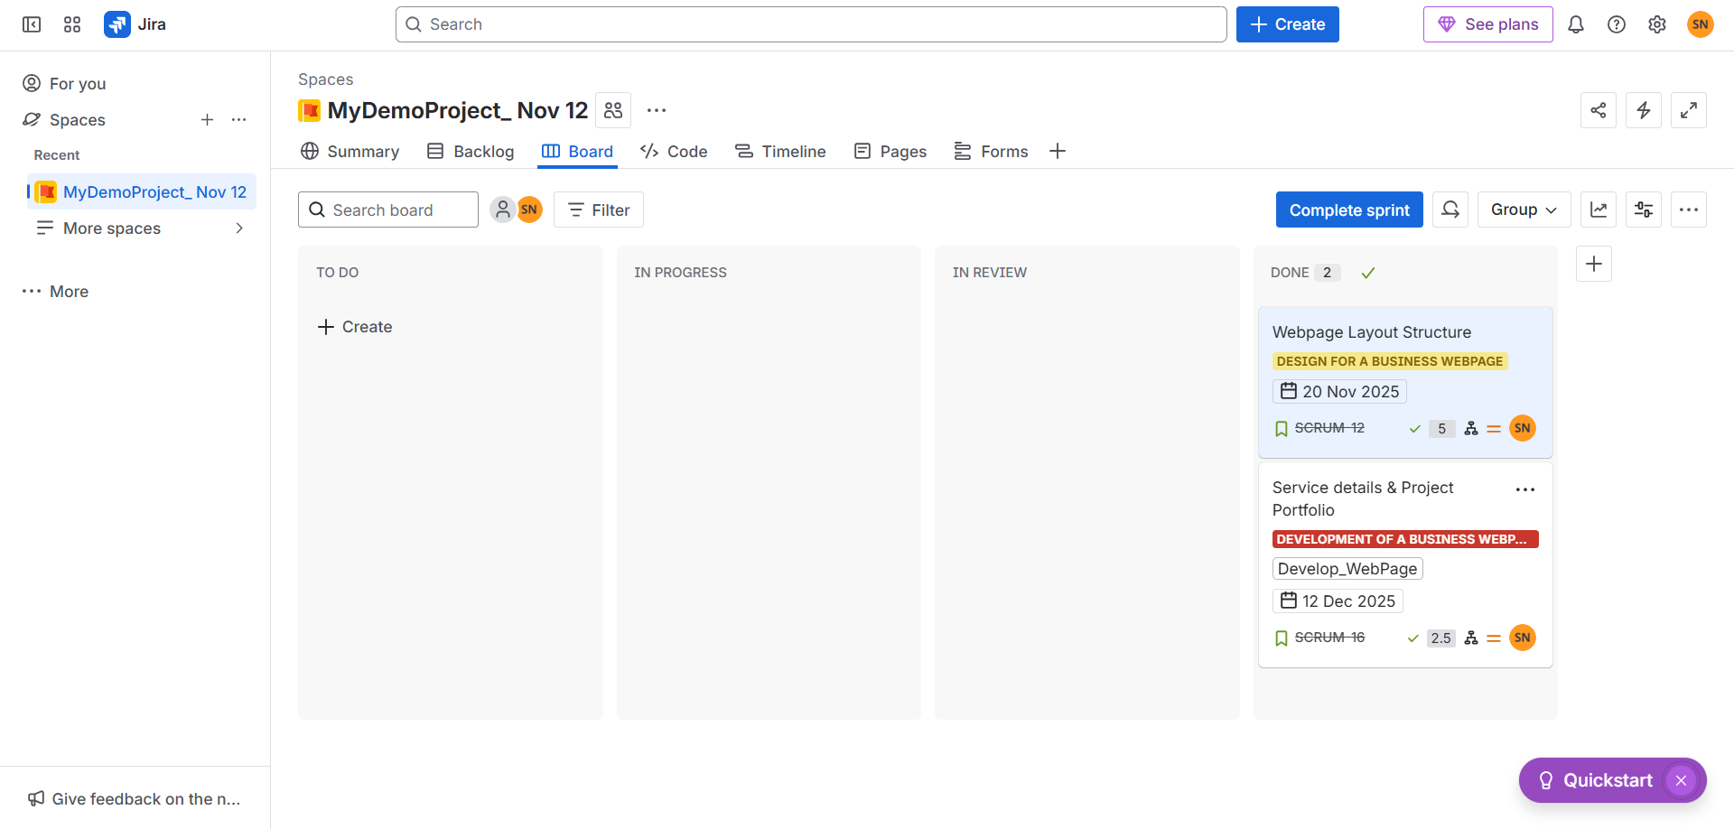

Complete Sprint:
